- Make sure in “net2 server configuration” under the general tab, “display reader LEDs in OEM style must be unchecked
Hide reader LED (not nano’s) must be selected instead to not merge the colours of the LEDs and display the correct colours.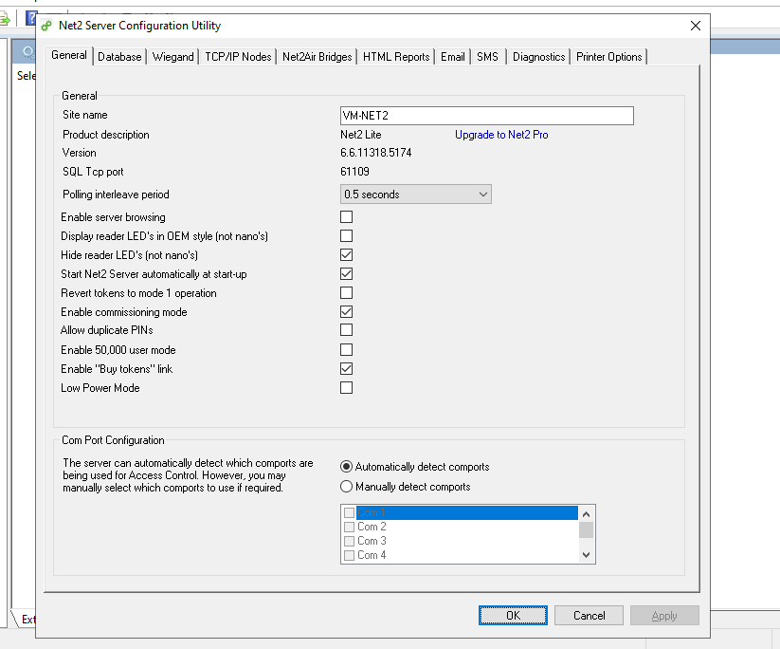
- Add a new node to the server configuration, click detect and a new node will auto populate.
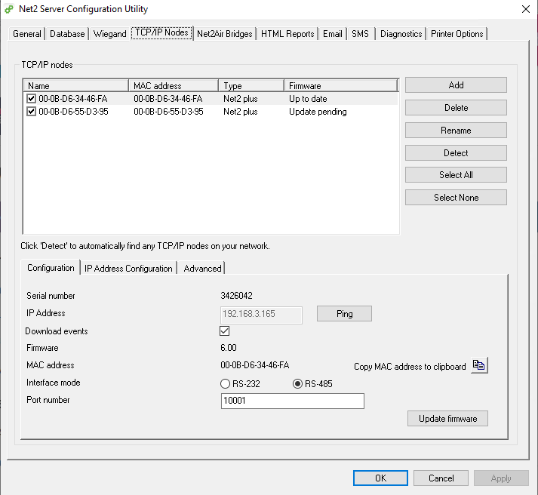
- make sure the reader is correctly attached to the net2 board, all the correct lights and Wiegand 0/1 is connected. (See below for wiring diagrams and examples)

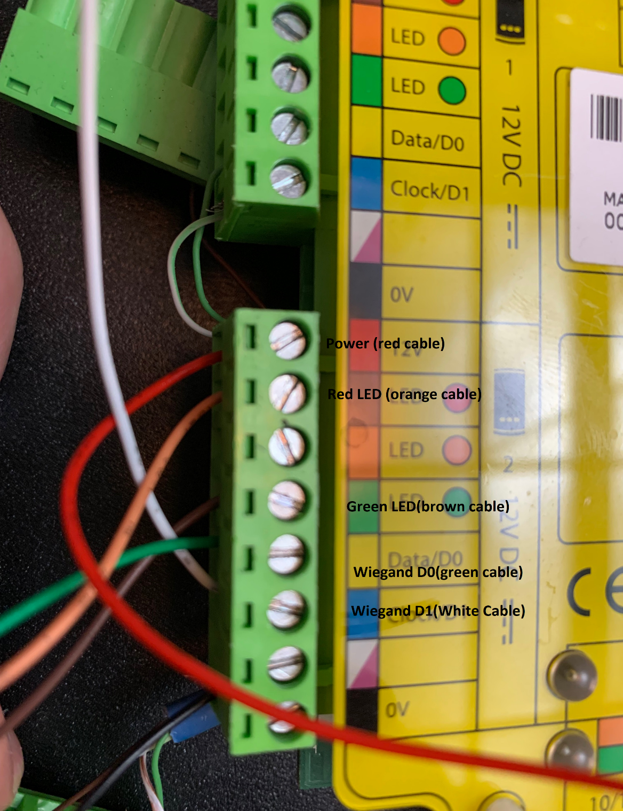

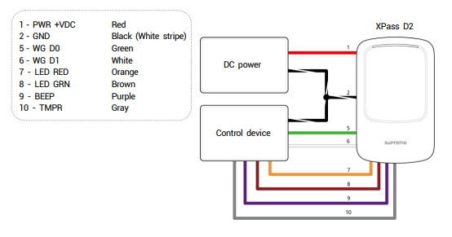
- In Paxton net2, configure the new ACU (Access Control Units) with the reader on the correct reader port (used reader port 2 select reader 2) add the Wiegand reader and set access times as needed

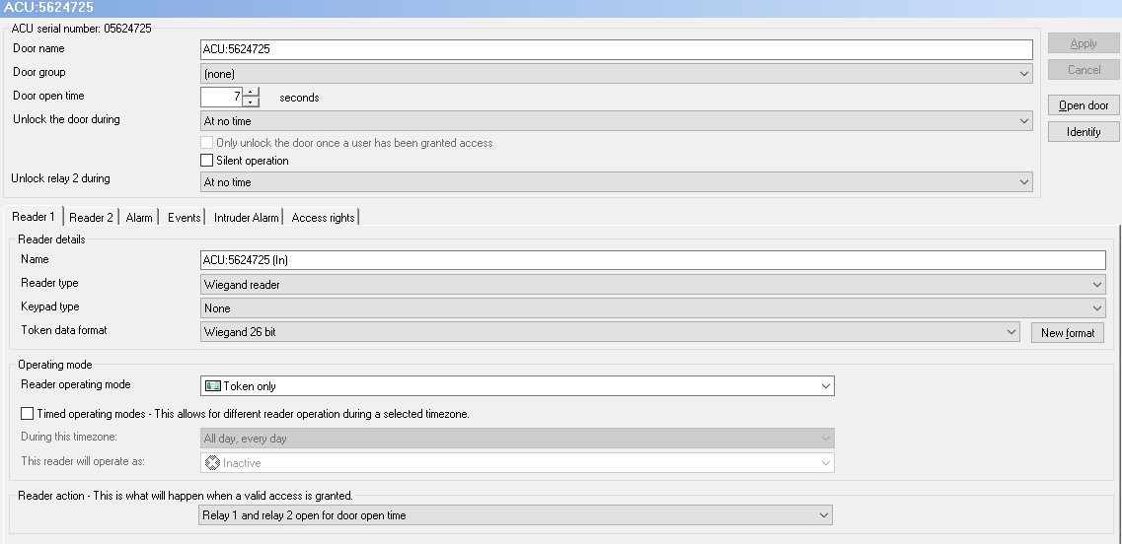
- Create a new user and configure their information as needed per the site needs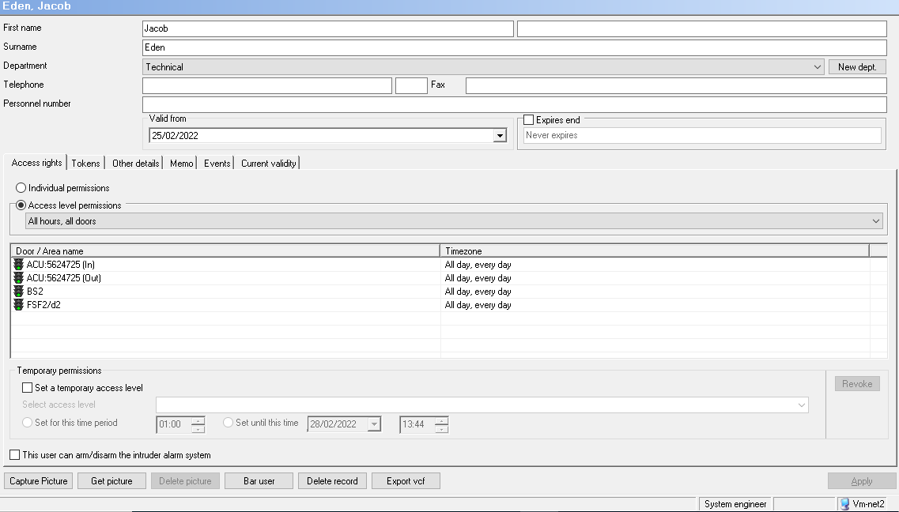
- Then select the “Tokens” tab and add a new token, from the list select unspecified token and then present the card to the reader. This will auto fill the “enter token number” field. Click ok
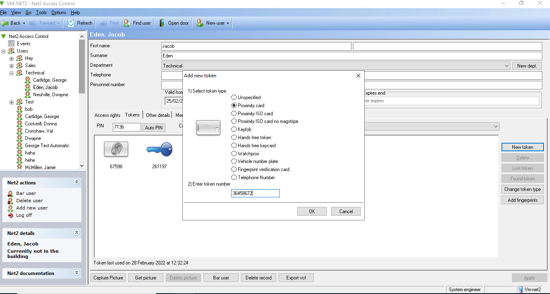
Alternatively, if the reader is unable to read the card at this stage present the card to authenticate with and take the token number from the Events log and manually enter in “enter token number” field
- Configure the settings for the D2 reader using the device manager application to the specification that is needed. Below will also have the LED configuration for access granted, card presented, and access denied.
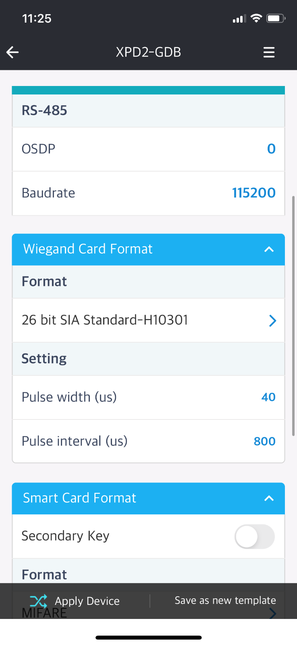
- Then present the card needed to test the lights on the D2 and the lights will flash as configured in step 7
Video 1. Shows the Device reader flashing red to show that there is no credential on the card that has the correct access level. The device warns the user with a sound to prompt failed authentication
Video 2 shows the device flashing green and makes a sound prompting the user for successful authentication. The board can also be heard clicking, this is the relay on the board opening allowing the door to unlock and grant passage.

Adding Mobile credentials.
- The site needs to be created with the Airfob website and the site code to the settings, 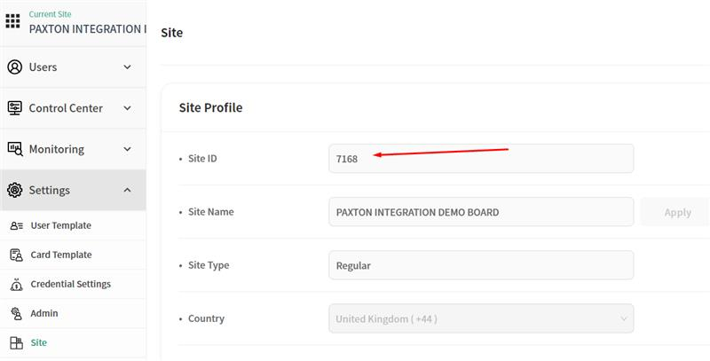
- Create accounts to access the airfob app on mobile phone to register the device
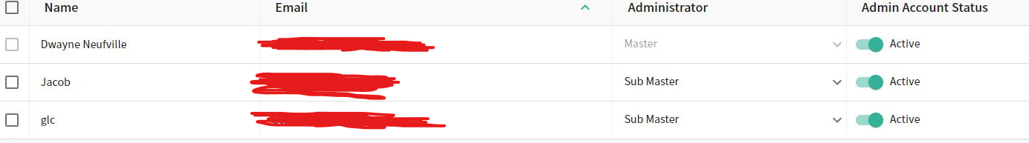
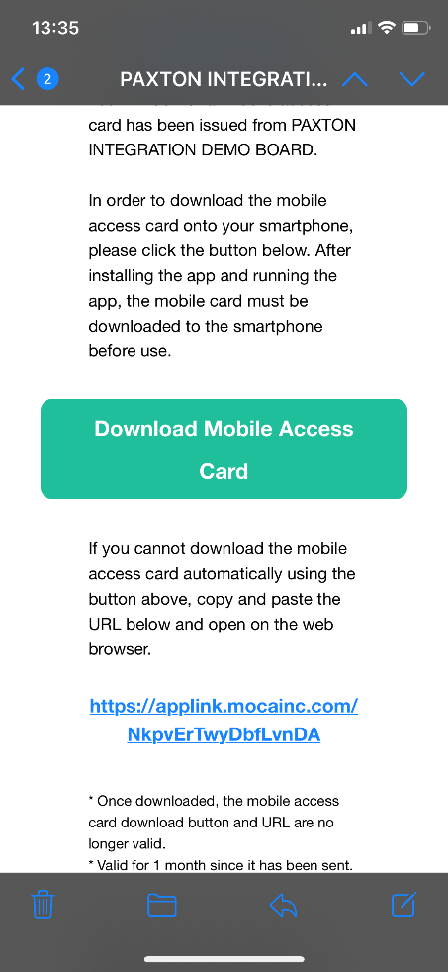
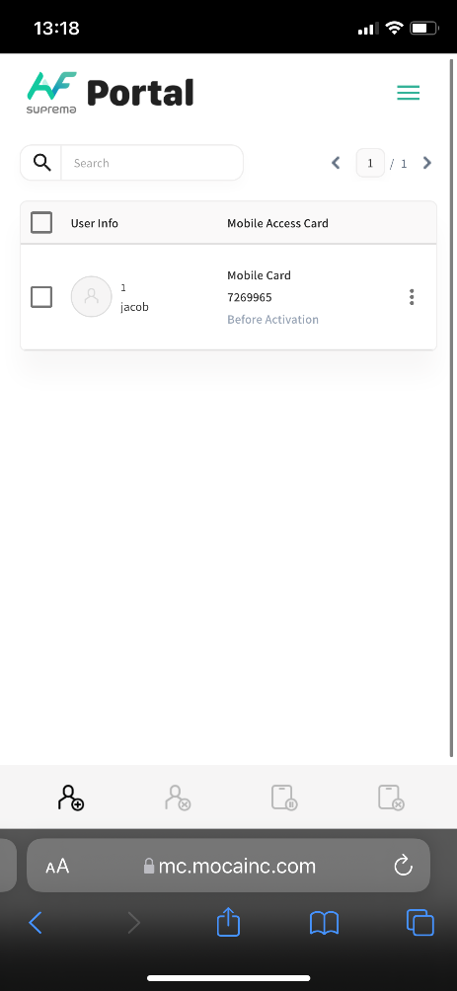
- Create a new user in the bottom left and enter the details. Id and card ID are auto set Send an email credential to the users you want to register with. Also, not down the ID that is auto assigned to you
Auto generated Mobile card token

- Click the 3 lines in the top right of the app, proceed to the bottom and click “device registration” sign in and select the site. Click the second option to register a device and a list will appear
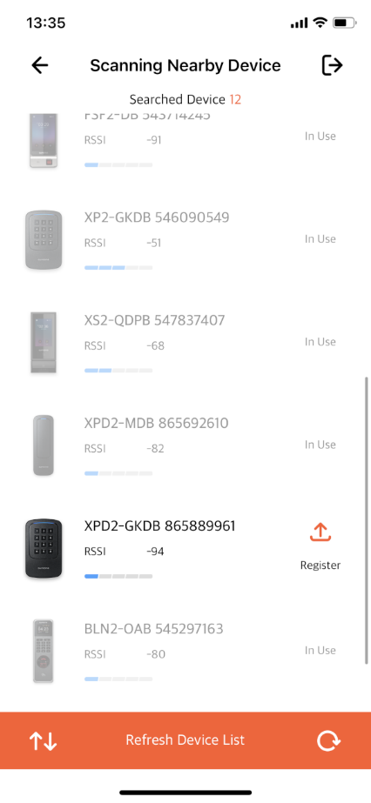
a device list appears with the signal strength of devices, select the strongest signal one
After the device is registered you can now test the usage on the device to see if it has correctly registered. The device will fail to authenticate until it is registered in net2

- After the device is registered you can now test the usage on the device to see if it has correctly registered. The device will fail to authenticate until it is registered in net2
- In net2 Select the user you wish to add the mobile credential too, select “tokens” and add a new token. Select the hands-free token and enter the ID from the airfob website that was auto assigned and click ok
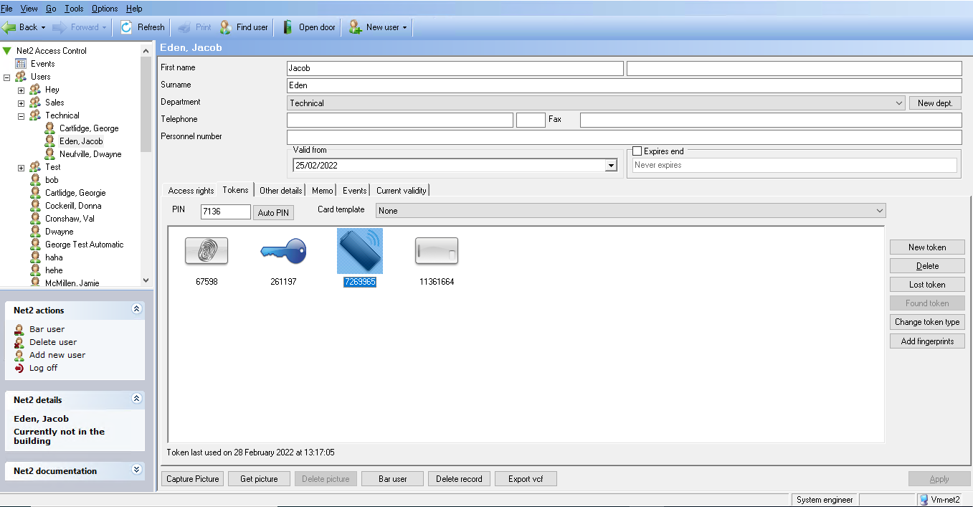
Airfob will now authenticate on the Paxton net2 software and release the board

FSF2 (Face Station F2) face input token
- Select the user you wish to add the token too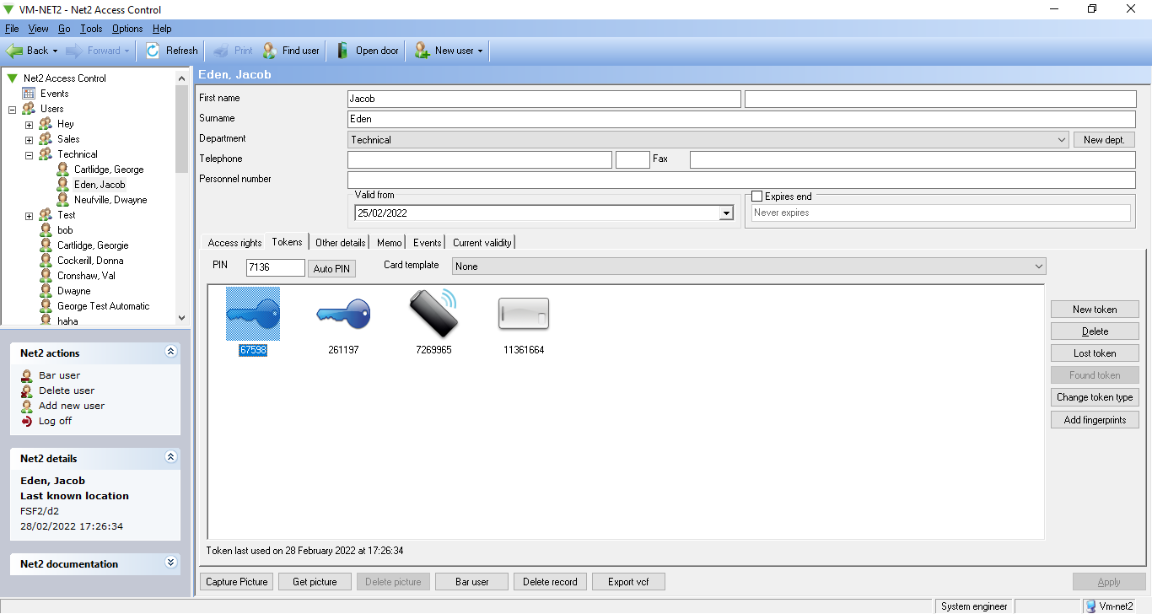
- Add the TTL input cable to the back of the facestation f2 and wire the red TTL IN0 cable to the red LED and the Yellow TTL IN1 cable to the Green LED and both ground cables in to the Wiegand ground for successful authentication
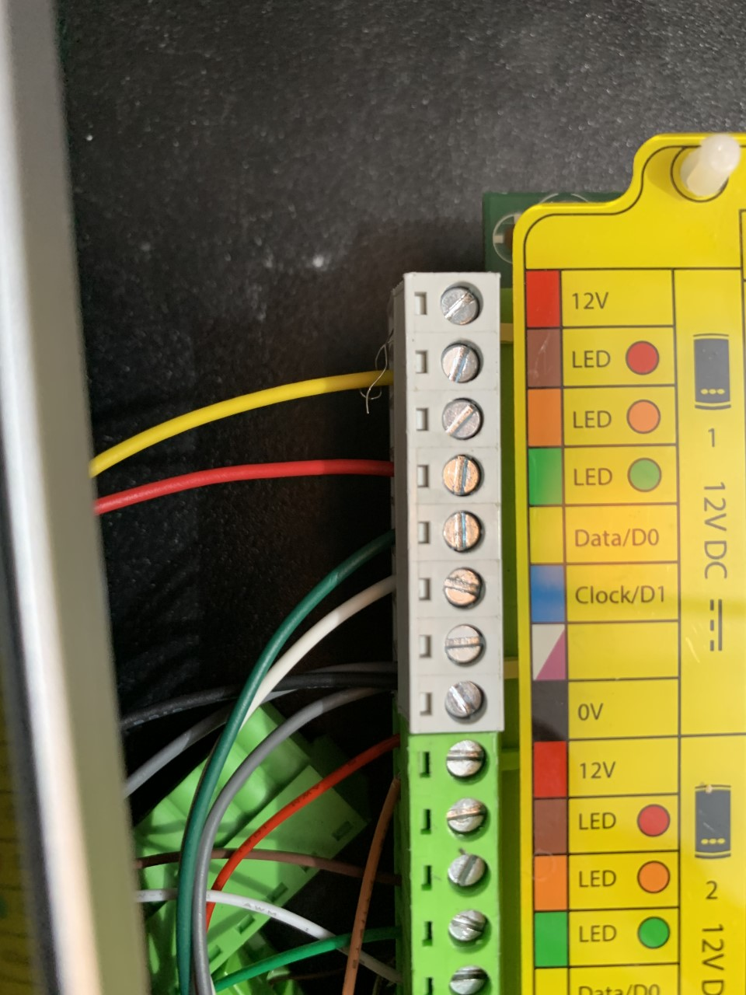
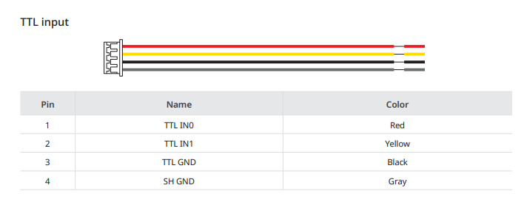

- In Paxton net 2 select the option add fingerprints, this will bring up the suprema integration menu, log in.
- After successful log in proceed down to face, select one of the faces and select your device you wish to scan the face with.
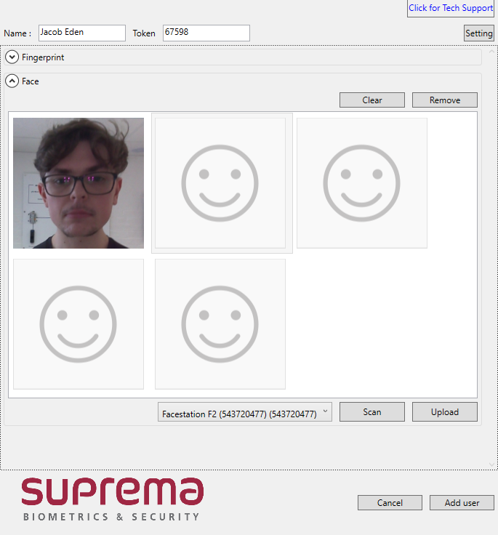
3
2
1
Insert the new unspecified token number here
- Scan your face on the device, when successful it will appear in the integration software.
Please note that this will use the same token as a fingerprint, so if you have a pre-existing fingerprint token, please create a new unspecified token and enter the token number at the top
- Add the new user and this will add the token to both the suprema integration and the net2 software
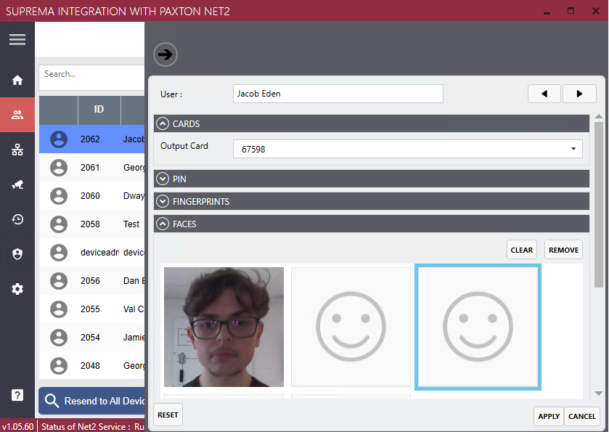

- Try to authenticate on the device and the ACU will grant access to the user and present the sound of the relay opening with a message in the “events” log on net2 granting access
Biostar 2 Trigger and action
1. Log in to biostar 2 with the admin account, proceed to the device menu list, add a device to the device list and then configure it.
2. scroll down to advanced and add a new trigger and action function, select input, and configure as shown below adding the trigger and action and the Wiegand data output
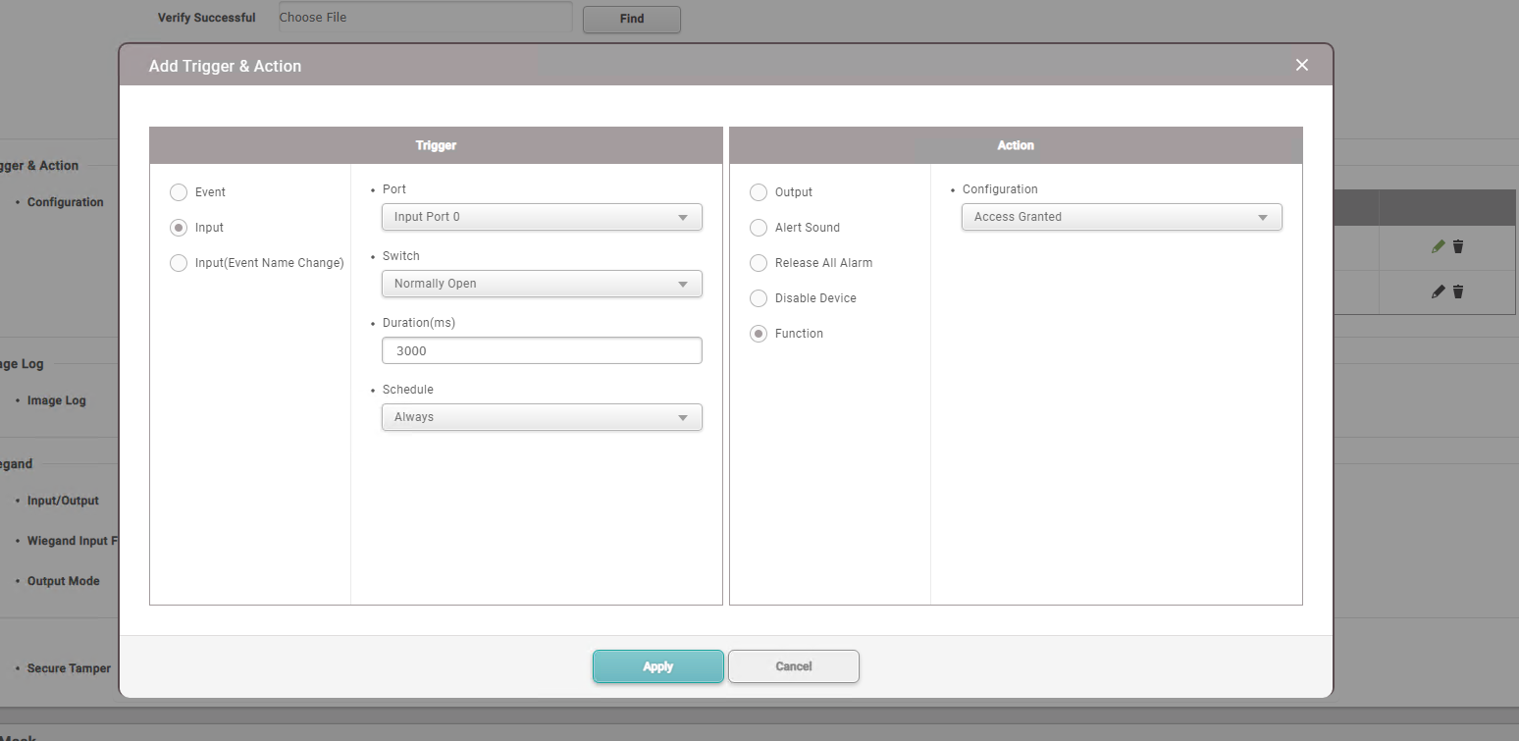
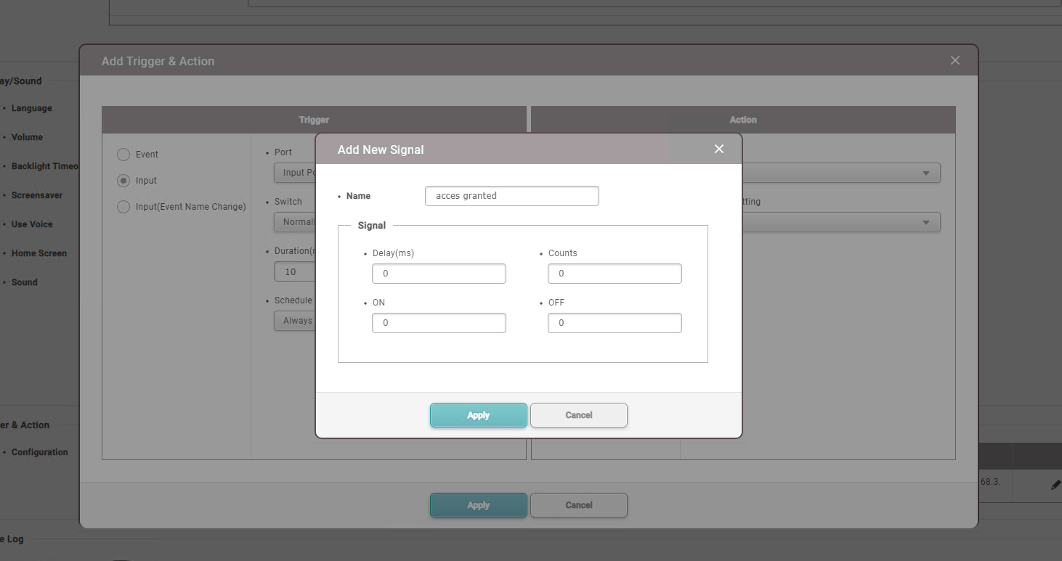

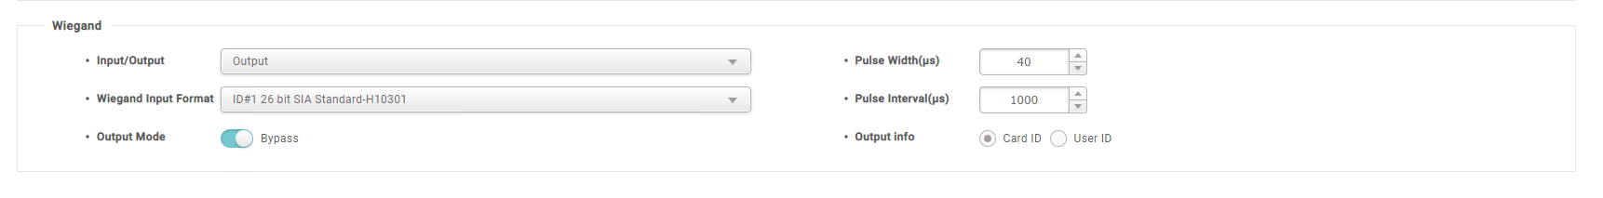
3. Ensure users on Biostar 2 are pulled from the F2 reader to allow the Access granted/ denied message to appear on the device. Right click device > manage users in the device > select everyone and upload.
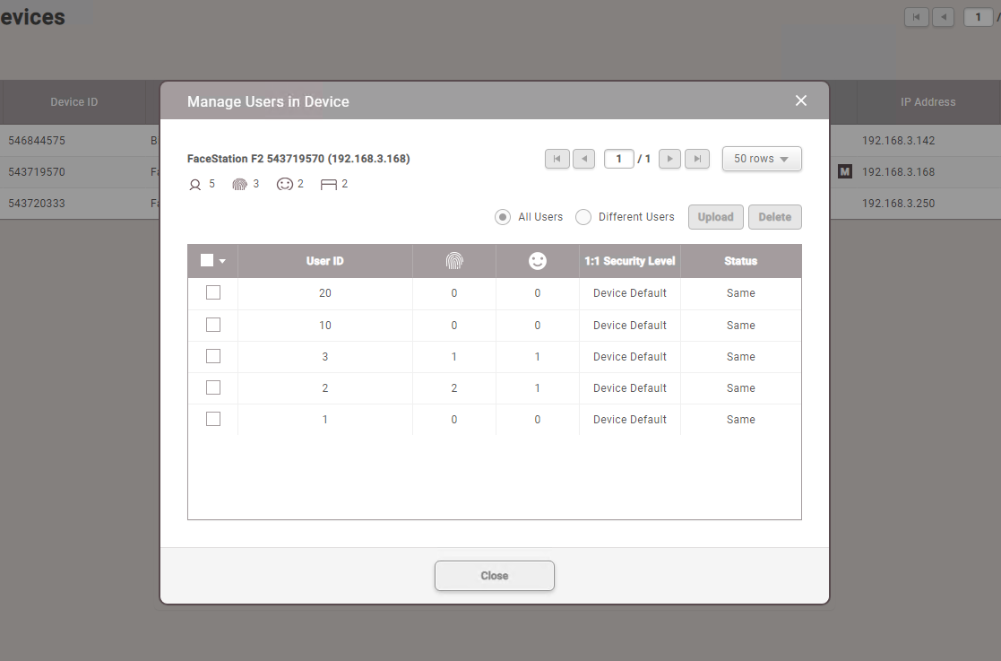
4. Add a csn card is biostar that uses the same number as one from Paxton net2 so the user can trigger the function set in the trigger and action function 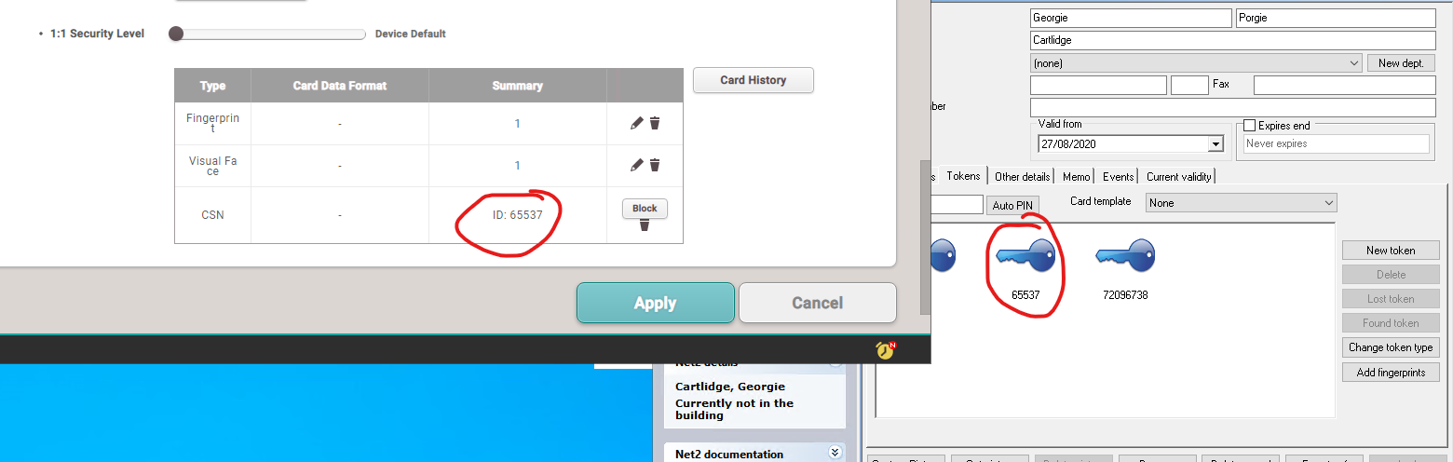
Video: when the user tries to Authenticate with the face a beep sound is made, and no message displayed. The user was unable to authenticate because user did not have a card assigned in biostar 2
5. authenticate on the device and the access granted/ denied message will appear on the screen

